Name: Pranali Sonawane
Subject: CCNA
Lab - Telnet Configuration :
First, we have taken 1 router, 1 switch, and 2 PCs. The PCs were connected using copper straight-through cables, and the router was also connected to the switch using a copper straight-through cable.
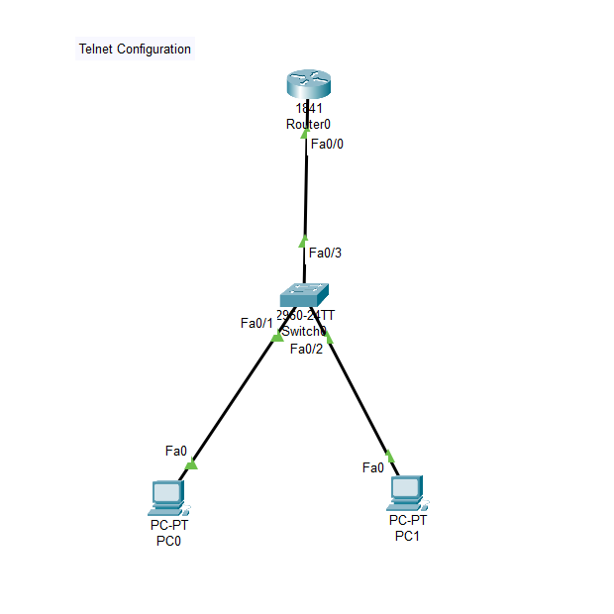
Open Router 0 – CLI prompt then type following commands
Router>enable
Router#configure terminal
Router(config)# hostname R1
R1(config)# interface fastEthernet 0/0
R1(config-if)# ip address 10.0.0.1 255.0.0.0
R1(config-if)#no shutdown
R1(config-if)#ip dhcp pool DHCP
R1(dhcp-config)# network 10.0.0.0 255.0.0.0
R1(dhcp-config)#default-router 10.0.0.1
R1(dhcp-config)#exit

We have given ip route using default routing to router 0 using command ip route.

Then we configured remote connection using commands:
R1(config)# line vty 0 15
R1(config-line)# password ccna
R1(config-line)# login
R1(config-line)# exit
R1(config)# enable secret ccnp

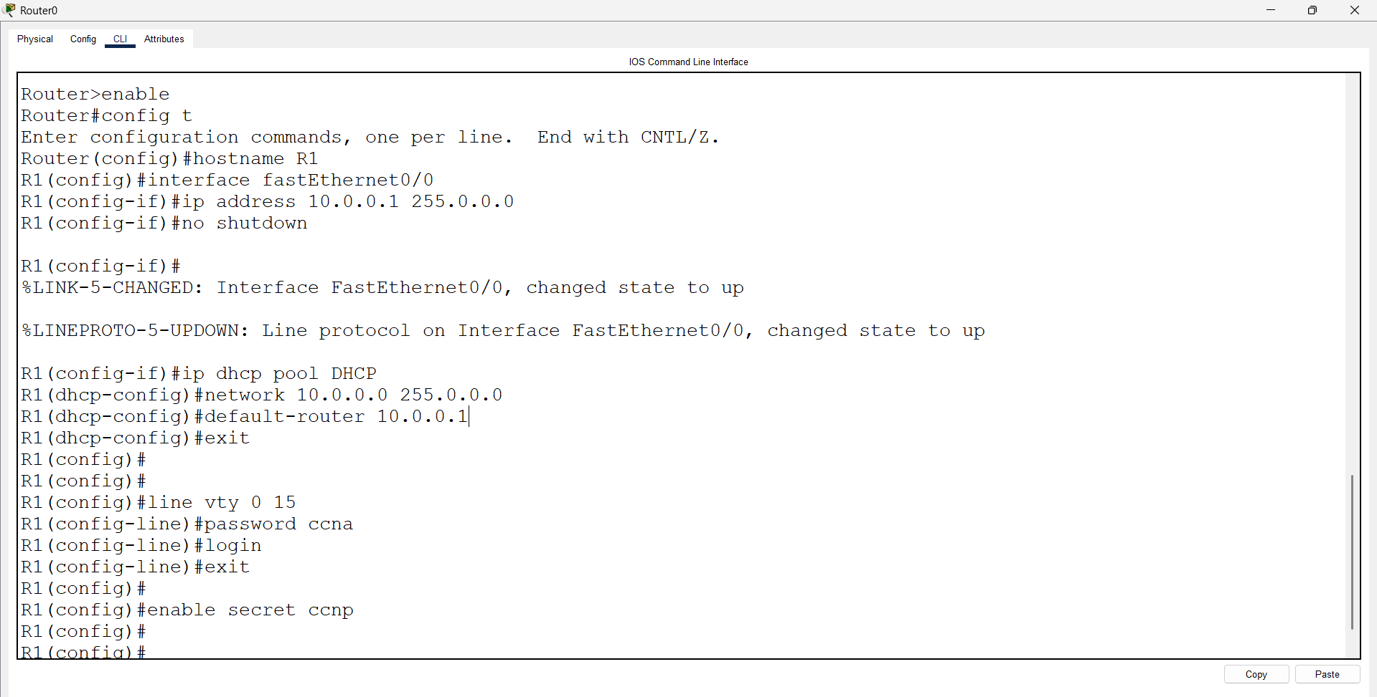
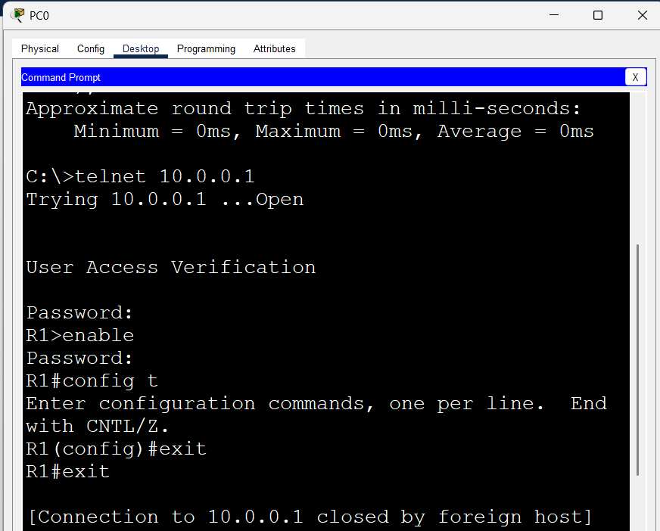

- First we have taken 2 Routers, 2 switches and 4 pc’s. Pc; connected using straight through cable and routers are connected using cross over cable.

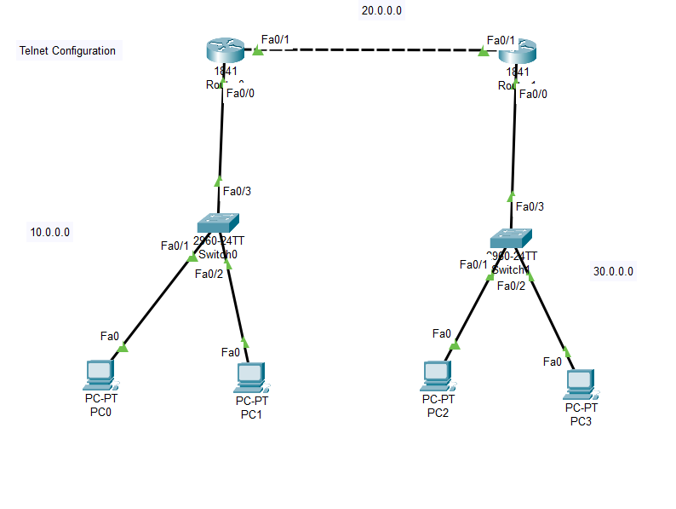
Open Router 0 – CLI prompt then type following commands
Router>enable
Router#configure terminal
Router(config)# hostname R1
R1(config)# interface fastEthernet 0/0
R1(config-if)# ip address 10.0.0.1 255.0.0.0
R1(config-if)#no shutdown
R1(config-if)#ip dhcp pool DHCP
R1(dhcp-config)# network 10.0.0.0 255.0.0.0
R1(dhcp-config)#default-router 10.0.0.1
R1(dhcp-config)#exit
R1(config)#interface fastEthernet 0/1
R1(config-if)#ip address 20.0.0.1 255.0.0.0
R1(config-if)#no shutdown
R1(config-if)#exit
R1(config)#ip route 0.0.0.0 0.0.0.0 20.0.0.2

We have given ip route using default routing to router 0 using command ip route.

Then we configured remote connection using commands:
R1(config)# line vty 0 15
R1(config-line)# password ccna
R1(config-line)# login
R1(config-line)# exit
R1(config)# enable secret ccnp

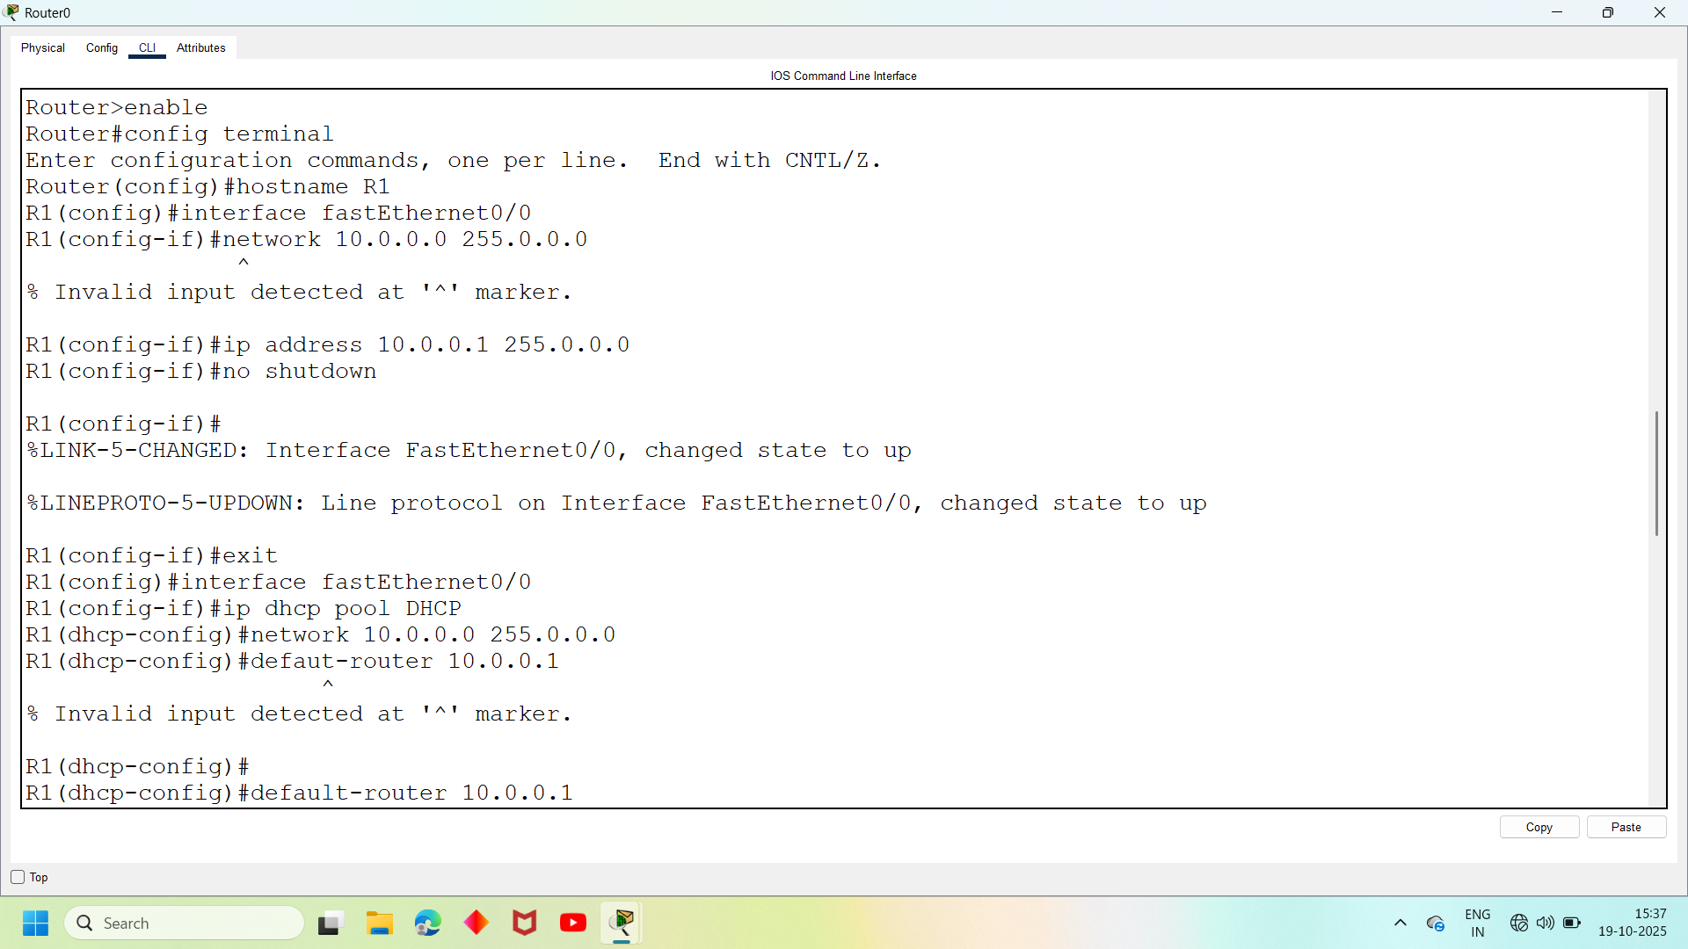
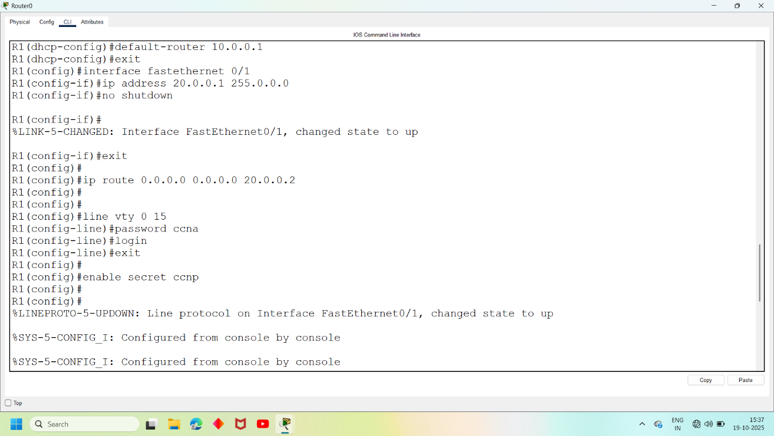

Open Router 1 – CLI prompt then type following commands
Router>enable
Router#configure terminal
Router(config)# hostname R2
R2(config)# interface fastEthernet 0/0
R2(config-if)# ip address 30.0.0.1 255.0.0.0
R2(config-if)#no shutdown
R2(config-if)#ip dhcp pool DHCP
R2(dhcp-config)# network 30.0.0.0 255.0.0.0
R2(dhcp-config)#default-router 30.0.0.1
R2(dhcp-config)#exit
R2(config)#interface fastEthernet 0/1
R2(config-if)#ip address 20.0.0.2 255.0.0.0
R2(config-if)#no shutdown
R2(config-if)#exit
R2(config)#ip route 0.0.0.0 0.0.0.0 20.0.0.1

We have given ip route using default routing to router 0 using command ip route.

Then we configured remote connection using commands:
R2(config)# line vty 0 15
R2(config-line)# password ccna
R2(config-line)# login
R2(config-line)# exit
R2(config)# enable secret ccnp

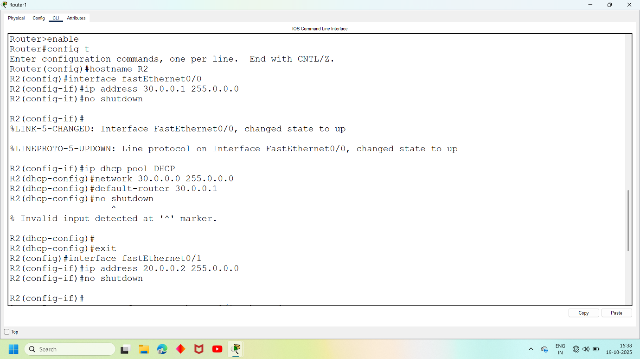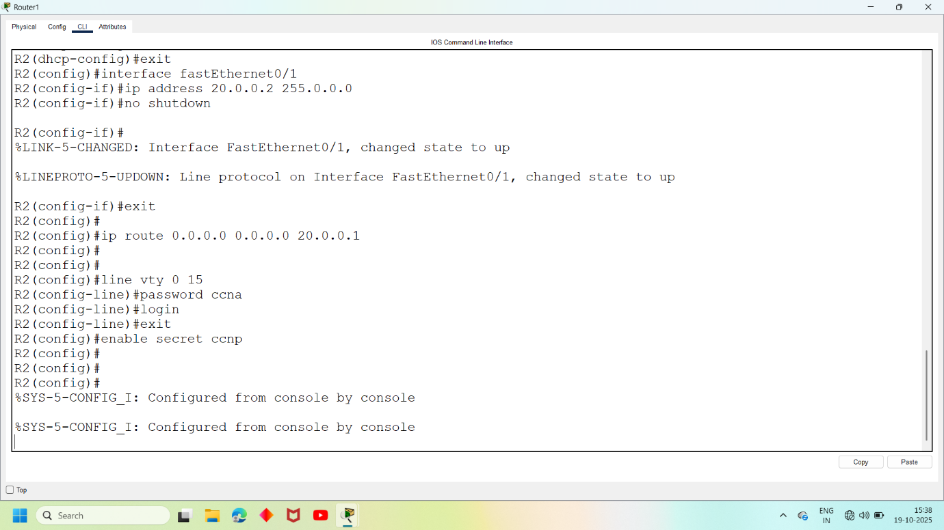

Then we opened pc0—desktop—cmd and entered command :
C:\telnet 20.0.0.2
It will connect router and ask password for user access verification enter mentioned password then
R2> enable
Password:
It wil again ask for secret password enter that password now you remotely got access for router0

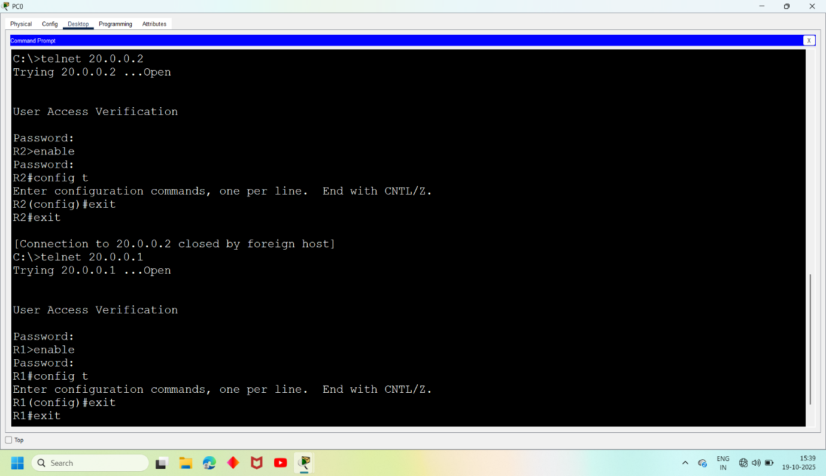

Then we opened pc2—desktop—cmd and entered command :
C:\telnet 20.0.0.1
It will connect router and ask password for user access verification enter mentioned password then
R1> enable
Password:
It wil again ask for secret password enter that password now you remotely got access for router 1

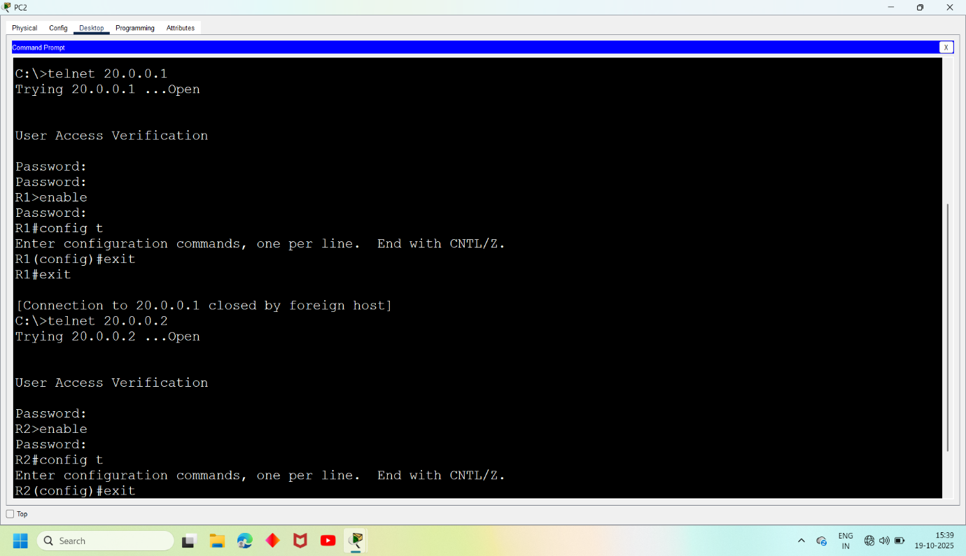

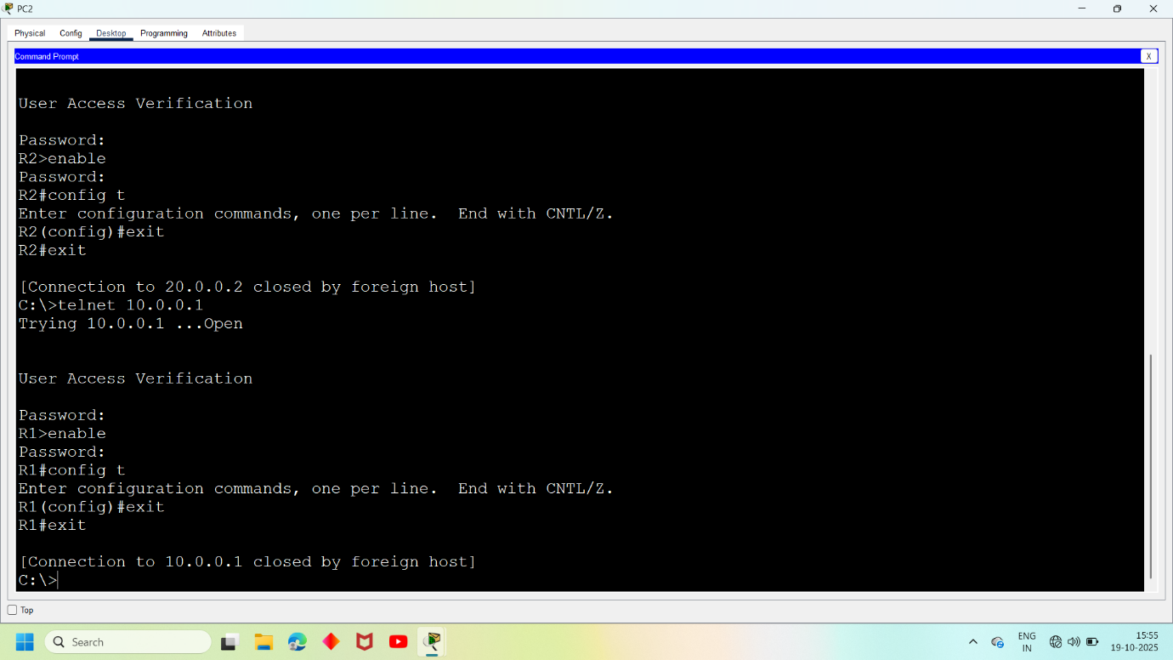

- First Take 3 Routers (Ex: 1841), 3 Switches And 6 Pc’s, Connect Routers, Switches And Pc’s Using Straight Through Cables.

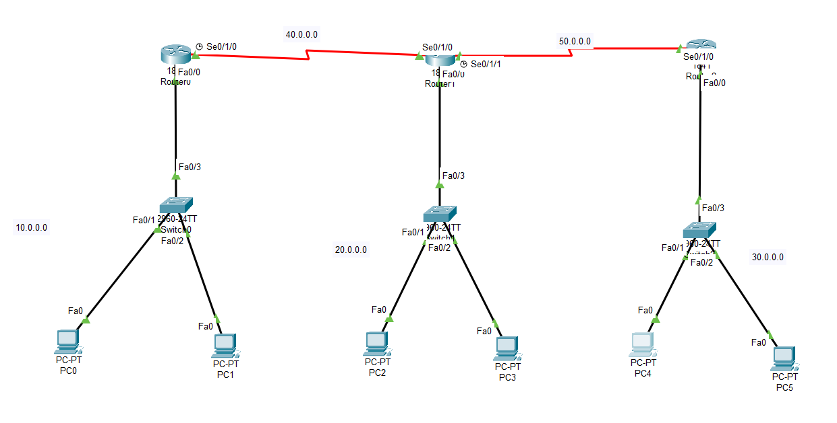

Open Router 0 – CLI prompt then type following commands
Router>enable
Router#configure terminal
Router(config)# hostname R1
R1(config)# interface fastEthernet 0/0
R1(config-if)# ip address 10.0.0.1 255.0.0.0
R1(config-if)#no shutdown
R1(config-if)#ip dhcp pool DHCP
R1(dhcp-config)# network 10.0.0.0 255.0.0.0
R1(dhcp-config)#default-router 10.0.0.1
R1(dhcp-config)#exit
R1(config)#interface serial 0/1/0
R1(config-if)#ip address 40.0.0.1 255.0.0.0
R1(config-if)#no shutdown
R1(config-if)#exit
R1(config)#ip route 0.0.0.0 0.0.0.0 40.0.0.2

We have given ip route using default routing to router 0 using command ip route.

Then we configured remote connection using commands:
R1(config)# line vty 0 15
R1(config-line)# password ccna
R1(config-line)# login
R1(config-line)# exit
R1(config)# enable secret ccnp

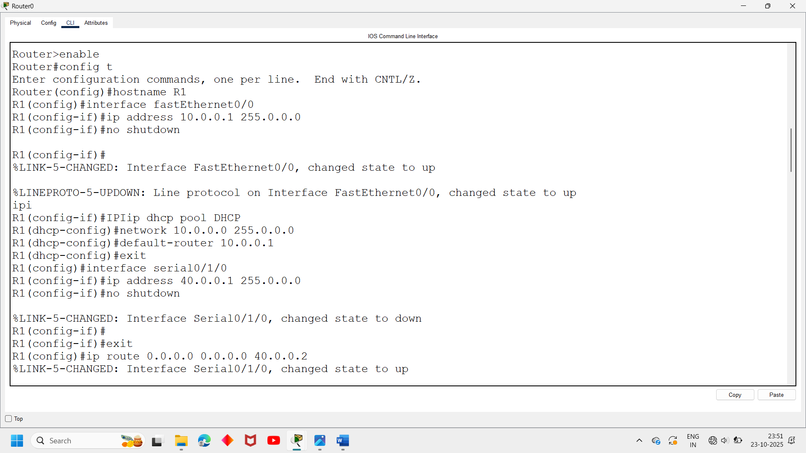
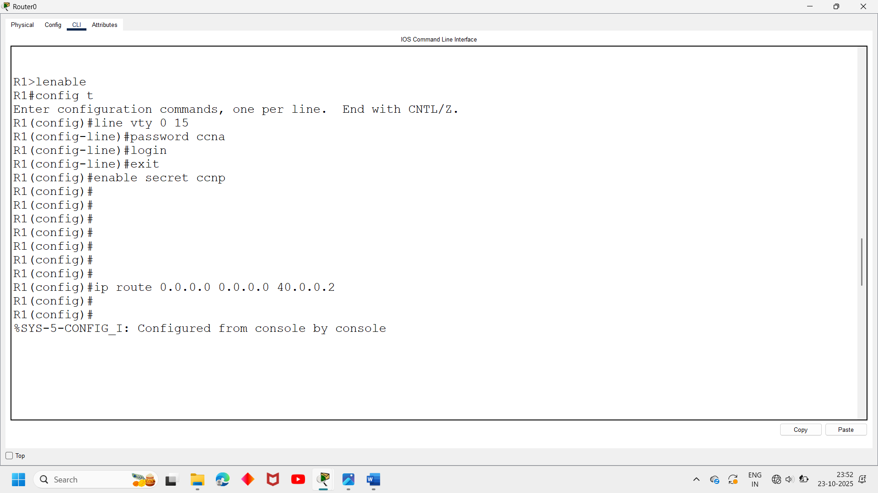

Open Router 1 – CLI prompt then type following commands
Router>enable
Router#configure terminal
Router(config)# hostname R2
R2(config)# interface fastEthernet 0/0
R2(config-if)# ip address 20.0.0.1 255.0.0.0
R2(config-if)#no shutdown
R2(config-if)#ip dhcp pool DHCP
R2(dhcp-config)# network 20.0.0.0 255.0.0.0
R2(dhcp-config)#default-router 30.0.0.1
R2(dhcp-config)#exit
R2(config)#interface serial 0/1/0
R2(config-if)#ip address 40.0.0.2 255.0.0.0
R2(config-if)#no shutdown
R2(config-if)#exit
R2(config)#interface serial 0/1/1
R2(config-if)#ip address 50.0.0.1 255.0.0.0
R2(config-if)#no shutdown
R2(config-if)#exit
R2(config)#ip route 0.0.0.0 0.0.0.0 40.0.0.1
R2(config)#ip route 0.0.0.0 0.0.0.0 50.0.0.2

We have given ip route using default routing to router 0 using command ip route.

Then we configured remote connection using commands:
R2(config)# line vty 0 15
R2(config-line)# password ccna
R2(config-line)# login
R2(config-line)# exit
R2(config)# enable secret ccnp

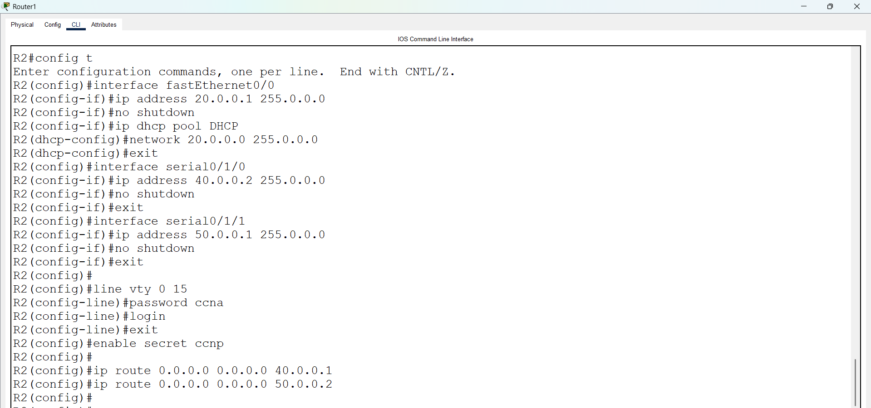

Open Router 2 – CLI prompt then type following commands
Router>enable
Router#configure terminal
Router(config)# hostname R3
R3(config)# interface fastEthernet 0/0
R3(config-if)# ip address 30.0.0.1 255.0.0.0
R3(config-if)#no shutdown
R3(config-if)#ip dhcp pool DHCP
R3(dhcp-config)# network 30.0.0.0 255.0.0.0
R3(dhcp-config)#default-router 30.0.0.1
R3(dhcp-config)#exit
R3(config)#interface serial 0/1/0
R3(config-if)#ip address 50.0.0.2 255.0.0.0
R3(config-if)#no shutdown
R3(config-if)#exit
R3(config)#ip route 0.0.0.0 0.0.0.0 50.0.0.1

We have given ip route using default routing to router 0 using command ip route.

Then we configured remote connection using commands:
R3(config)# line vty 0 15
R3(config-line)# password ccna
R3(config-line)# login
R3(config-line)# exit
R3(config)# enable secret ccnp

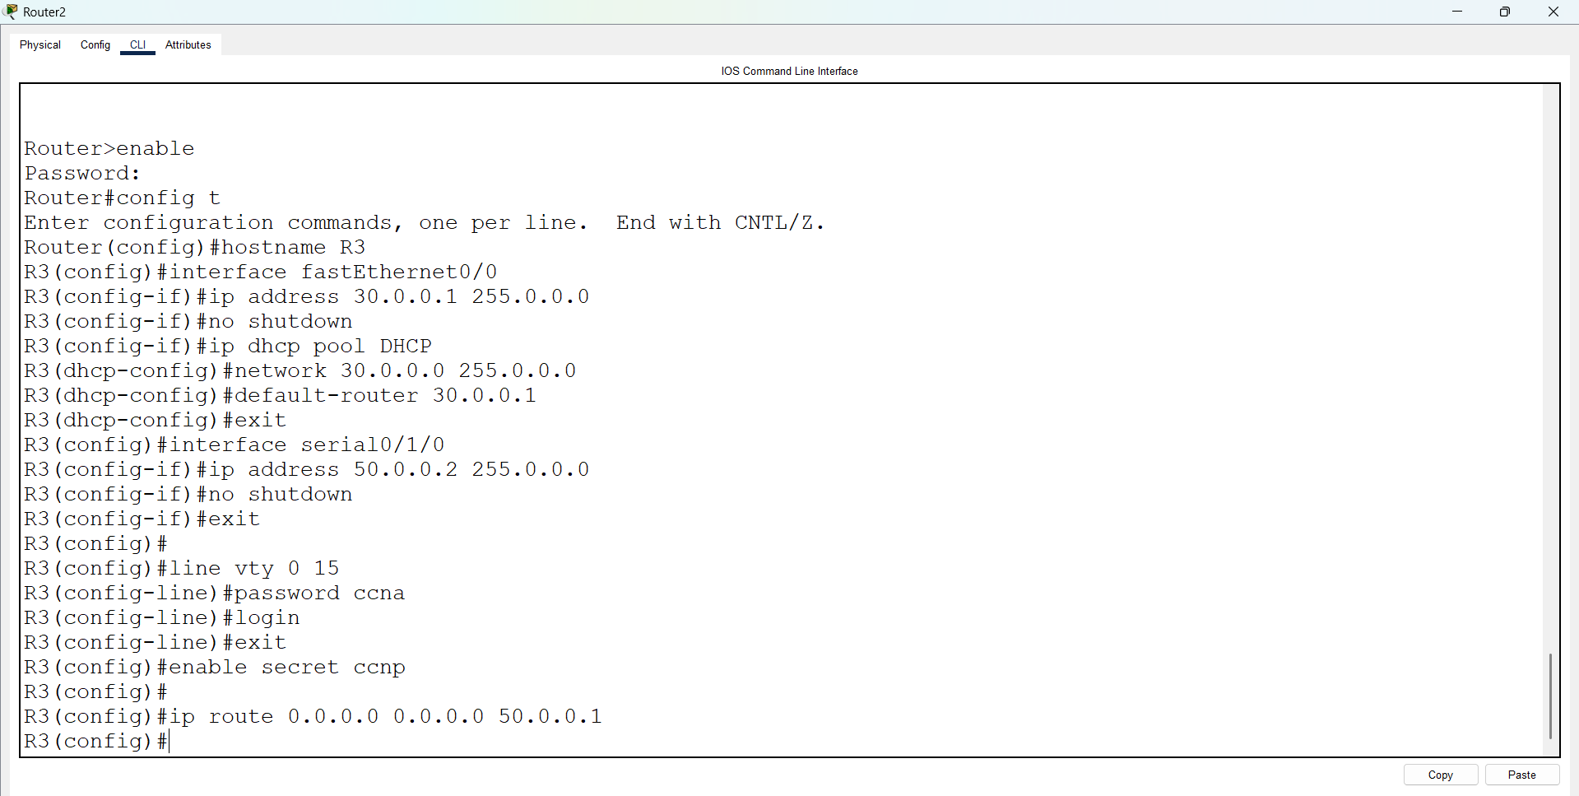

Then we opened pc0—desktop—cmd and entered command :
C:\telnet 20.0.0.1
It will connect router and ask password for user access verification enter mentioned password then
R2> enable
Password:
It wil again ask for secret password enter that password now you remotely got access for router0

